**Tokyo Olympics 2021**

**High Level Design –**

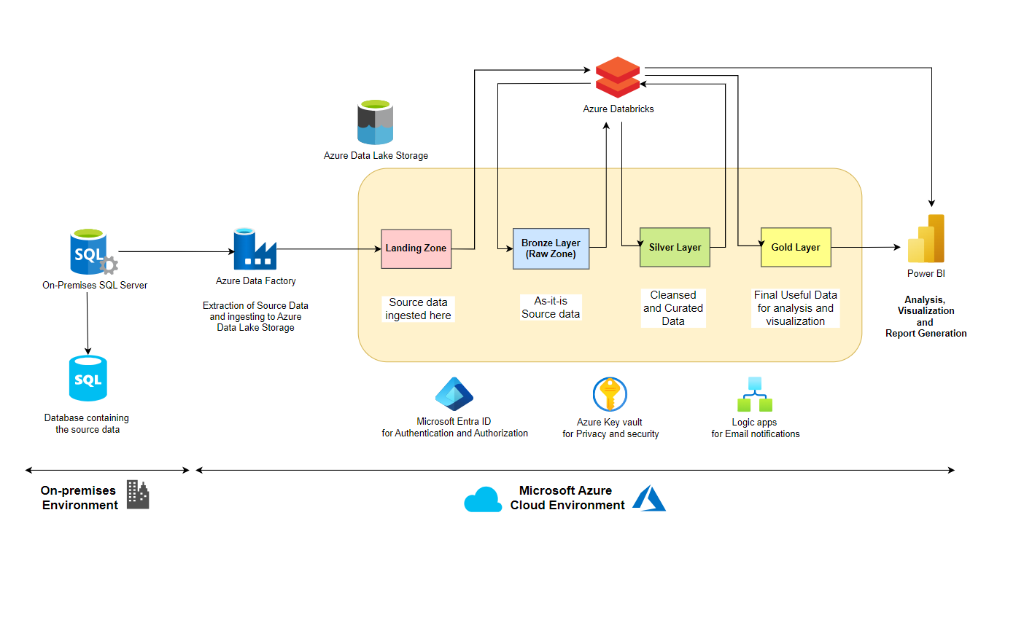

**Low Level Design –**

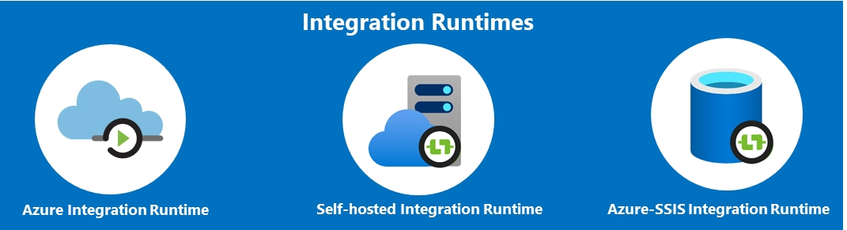

Self-Hosted Integration Runtime

Azure Data Factory (Pipelines and Activities)

ADLS LandingZone

On-Premises SQL Database Data



